BUS Voltage Fault

Author: 张岩
Reviewer：Eason

FAQ\Hybrid INV
Issue introduction

INV repeatedly reports “Bus Voltage Fault”.
Confirmation of basic information
[Photo]SN number of the inverter
[Photo]Collect the historical alarms to check the occurrence count and frequency.
Guidance for installer
Use a multimeter to measure the voltage at each MPPT, make sure that the Max. PV input voltage in Datasheet is not exceeded.If the measured voltage value is close to the maximum MPPT range threshold, it is recommended to reduce the number of photovoltaic panels in the corresponding sting.
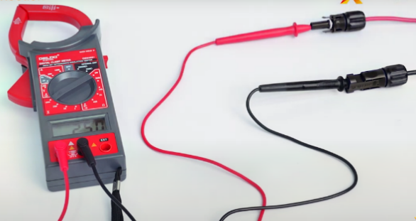
Situation1< Errors reported off-grid only >
Step1: Turn off all loads, then connect the loads one by one to detect the special load that is causing the error.
Step2:Restart the inverter and check whether the inverter recovers.
Situation2< Errors reported on-grid only >
Power generation equipment such as other inverters or generators on the grid line will be turned off, then observe whether the inverter is back to normal.
Situation3< Meter fault also report >
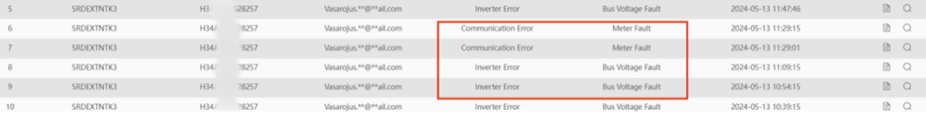
Step1: Disable the Phase Unbalanced function.
Settings path: Setting→Advanced Setting→Phase Unbalanced
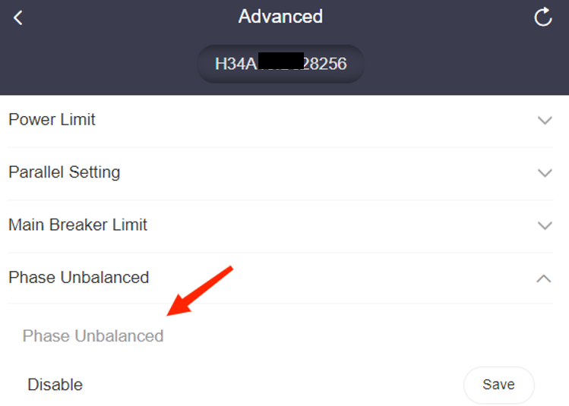
Step2: Check the phase sequence of the meter or CT,then restart the inverter.
Information check list
If you have completed the above <Guidance for installer>, and the problem is still not solved, please collect the following troubleshooting information and send them to the R&D.
1.[Photo]Inverter information including SN and registration numbers.
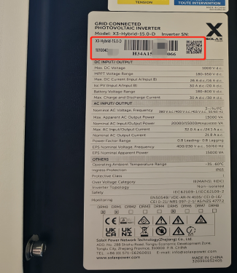
2.[Photo]Historical alarms.

3.[Photo]Phase Unbalanced settings.
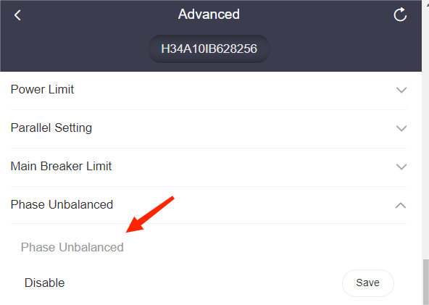
4.[Photo]Voltage at each MPPT.
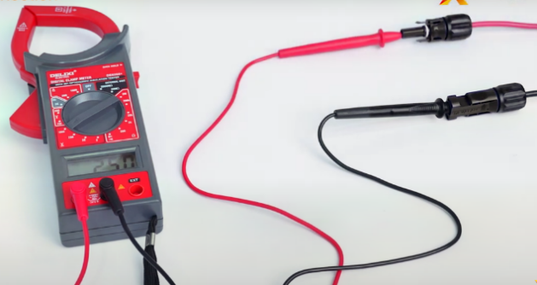
5. Special loads that are detected.

